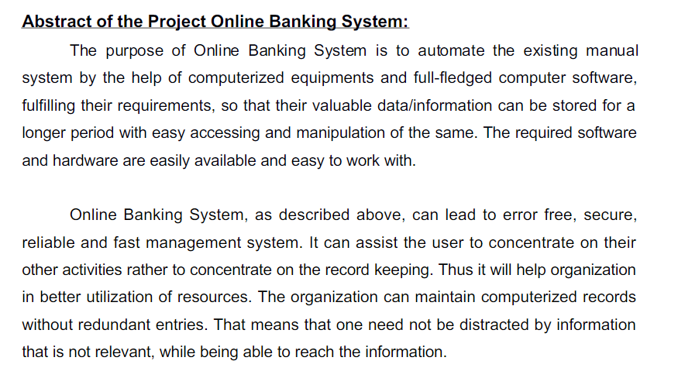

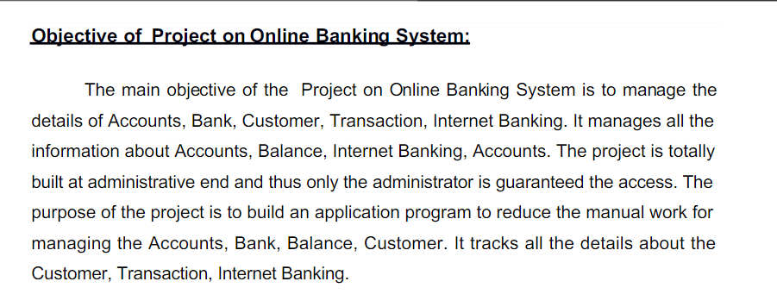

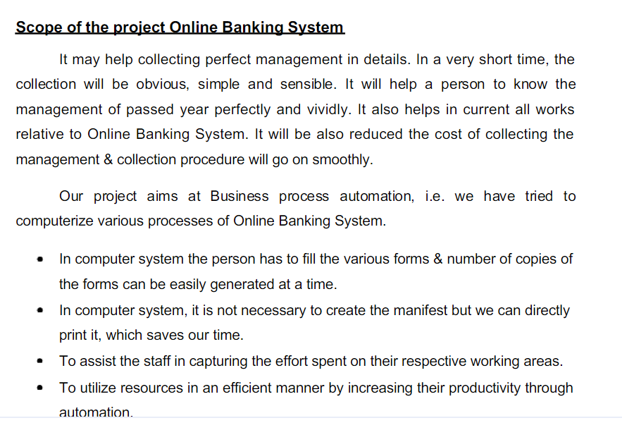

Architecture diagram

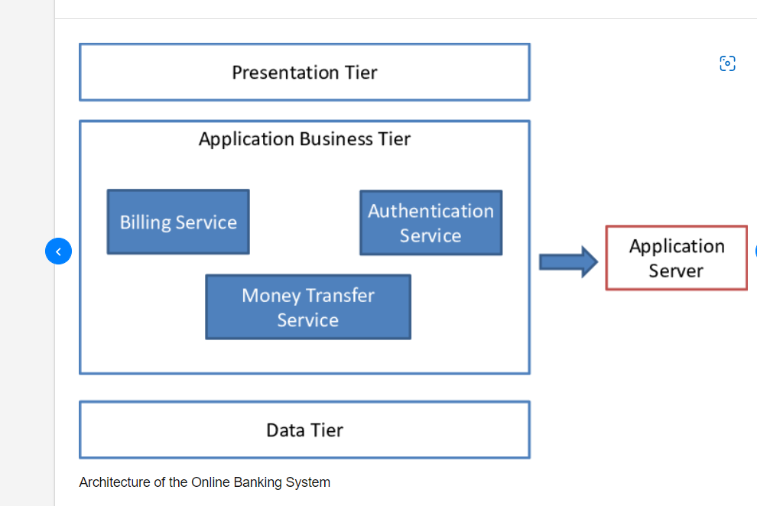

UML ONLINE BANKING SYSTEM

<https://www.startertutorials.com/uml/uml-diagrams-online-banking-system.html>